Course Name: | Competitive Programming Laboratory (216U01L401) | Semester: | IV
Date of Performance: | 11/04/2025 | DIV/ Batch No: | C3
Student Name: | Om Satish Thanage | Roll No: | 16010123217

Experiment No: 5
Title: To implement a competitive programming problem on a platform (eg. Leetcode) optimised using the dynamic programming approach.

Aim and Objective of the Experiment:
- Understand the concepts of dynamic programming approach.
- Apply the concepts to solve the problem.
- Implement the solution to given problem statement.
- Create test cases for testing the solution.
- Analyze the result for efficiency of the solution.

COs to be achieved:
CO3: Solve intricate problems involving graphs, tree structures, and algorithms.

Books/ Journals/ Websites referred:
- https://leetcode.com/problems/burst-balloons/

Theory:
Bursting a balloon affects its neighbors. So instead of bursting left to right, think in reverse:
What if we choose the last balloon to burst in a subarray?
By fixing the last balloon in an interval, its neighbors are fixed (they don't change anymore), making it easier to calculate the coins earned.

Approach (Dynamic Programming)
- Add virtual balloons: Insert 1 at both ends of the array to handle edges easily. So,
nums = [1] + nums + [1]
- DP definition:
Let dp[left][right] be the maximum coins obtainable by bursting all balloons between left and right (exclusive).
- Recurrence:
For every possible i between left+1 and right-1, assume i is the last balloon to burst between left and right.
Then:
dp[left][right] = max(dp[left][right],
nums[left] * nums[i] * nums[right]
+ dp[left][i]
+ dp[i][right])

- Build up: Use bottom-up DP to fill the dp table from smaller intervals to larger ones.
- Result: dp[0][n+1] gives the max coins for the full range.

Problem statement
You are given n balloons, indexed from 0 to n - 1. Each balloon is painted with a number on it represented by an array nums. You are asked to burst all the balloons.
If you burst the i^{th} balloon, you will get nums[i - 1] * nums[i] * nums[i + 1] coins. If i - 1 or i + 1 goes out of bounds of the array, then treat it as if there is a balloon with a 1 painted on it.
Return the maximum coins you can collect by bursting the balloons wisely.

Example 1:
Input: nums = [3,1,5,8]
Output: 167
Explanation:
nums = [3,1,5,8] --> [3,5,8] --> [3,8] --> [8] --> []
coins = 3*1*5 + 3*5*8 + 1*3*8 + 1*8*1 = 167
Example 2:
Input: nums = [1,5]
Output: 10

Constraints:
- n == nums.length
- 1 <= n <= 300
- 0 <= nums[i] <= 100

Code :
class Solution {
public:
int maxCoinsHelper(int i, int j, vector<int> &nums, vector<vector<int>> &dp) {
if (i > j) return 0;
if (dp[i][j] != -1) return dp[i][j];
int maxCoins = INT_MIN;

for (int k = i; k <= j; k++) {
int coins = nums[i - 1] * nums[k] * nums[j + 1];
int remainingCoins = maxCoinsHelper(i, k - 1, nums, dp) + maxCoinsHelper(k + 1, j, nums, dp);

maxCoins = max(maxCoins, coins + remainingCoins);
}

return dp[i][j] = maxCoins;
}
int maxCoins(vector<int> &nums) {
int n = nums.size();
nums.insert(nums.begin(), 1);
nums.push_back(1);
vector<vector<int>> dp(n + 2, vector<int>(n + 2, -1));
return maxCoinsHelper(1, n, nums, dp);
}
};

Output:
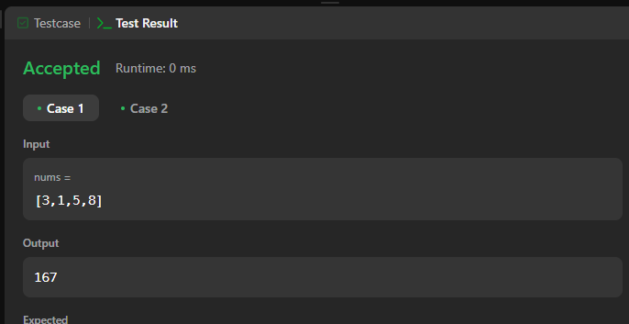

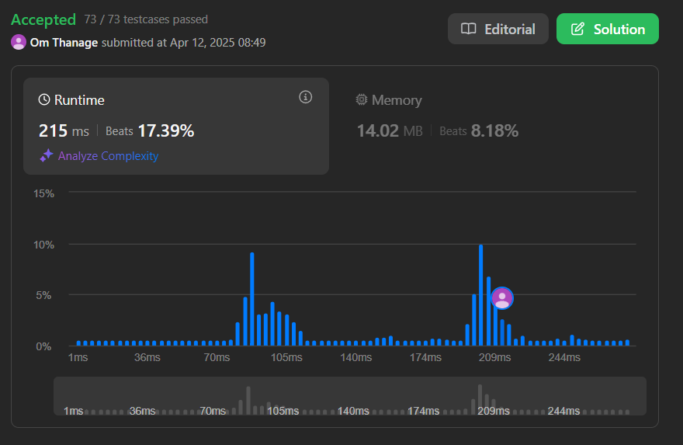

Conclusion:
implemented a competitive programming problem on a platform (eg. Leetcode) optimised using the dynamic programming approach successfully.

